

Startup Guide

STEP 1 – Login to the system

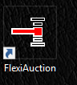

Click the FLEXIAUCTION shortcut on your desktop to start the program

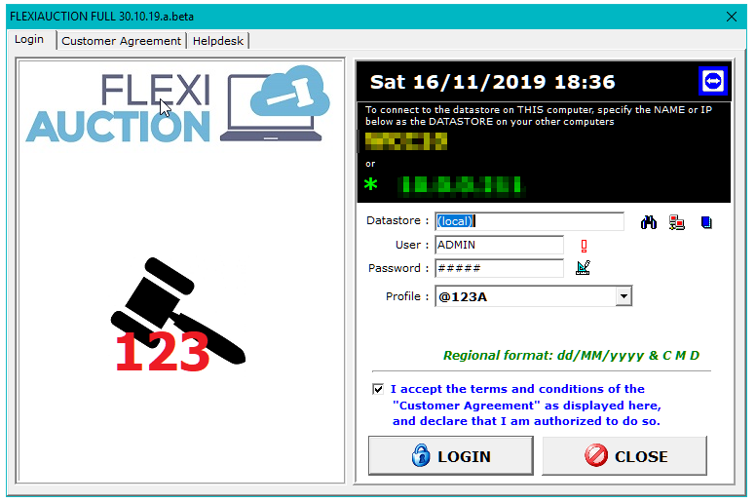

Specify the computer to use as default datastore.
Computers in a network should all use the same computer as datastore.
If you leave this blank or enter a dot, the system will use the local computer.
The default username is ADMIN and the default password is ADMIN
Select the profile to use (this will determine your invoice layouts, logos, etc.)
You must tick the “I agree…” checkbox to continue. (Please read the terms first)

Click LOGIN

STEP 2 – Main form is displayed

Menu Bar on top

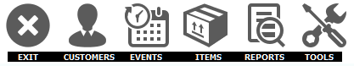

EXIT | Terminate program
CUSTOMERS | Maintain customers (customers refer to either buyers or sellers)
EVENTS | Maintain events (an auction is called an event in the system)
ITEMS | Maintain items (an item is any countable object or entity you are selling)
REPORTS | Generate reports
TOOLS | Various utility functions (backup, settings, users, maintenance, etc)

Active Event (at this stage no event is active)
Vendueroll grid (as no event is active the vendueroll grid is empty)

STEP 3 – Create a new Auction


Click on EVENTS to open the Events maintenance form.

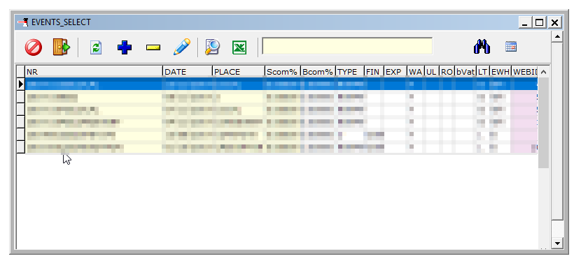

Click on ADD A NEW ITEM

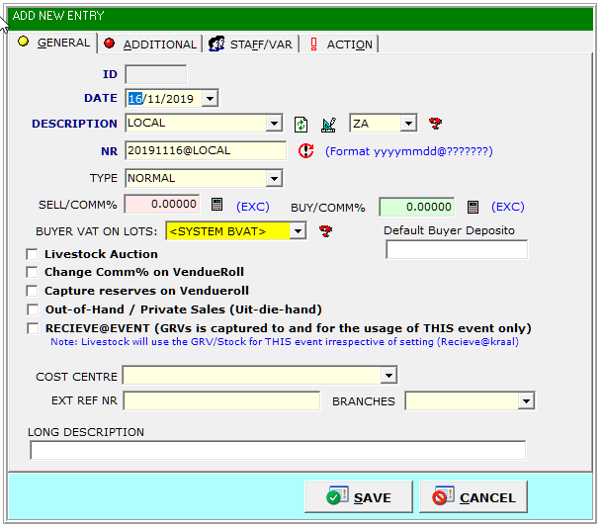

Specify the date, location info, type and commission for the auction.
NR must always be in the format YYYYMMDD@XXX where YYYYMMDD is the date
of the auction and XXX is your own short description.
Ensure that relevant tick boxes are ticked.

SAVE the Auction

The auction will be displayed in the grid area, highlight it and double-click to activate it.

On the main form the event will now be activated. All actions performed now,
will be registered against this event.

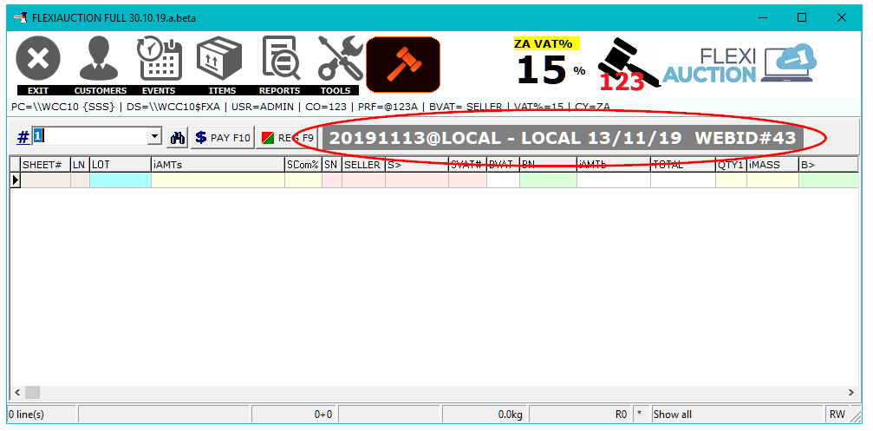

STEP 4 – Capture the Vendueroll

If not running, start FlexiAuction and Login to correct datastore. Activate your event.

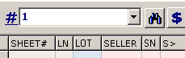

Enter the number to use as sheet number and press ENTER or click
The sheet numbers is used to organize your lots into different pages.
Usually “1” is entered as the first sheet to be created and used.
Blank Lots for the sheet is automatically added to the vendueroll.
Any number of sheets may be added, only enter the sheet number to use.
Press ENTER or double-click on the highlighted lot to change it.
(or right-click and click on CHANGE LOT or press F2)

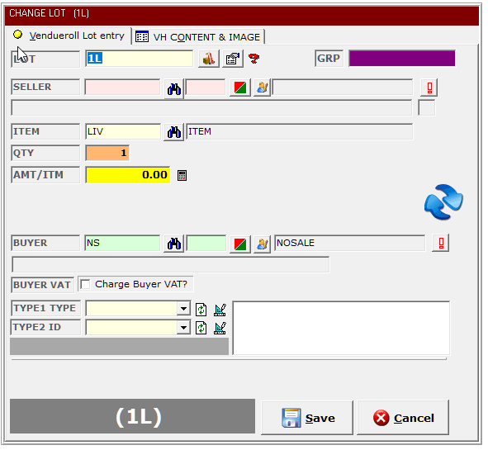

You will now be able to capture the details for this LOT:

LOT | Te lot number
SELLER | Click. Search for the seller by typing his surname  and then press ENTER or .  If the seller is in the list, press up/down keys to  highlight the seller, press ENTER of double-click to select  as seller for this lot.  If the customer is not in the list, the customer  should be added fist. Click +,enter the name and other  relevant details for this seller. Click SAVE  Press ENTER of double-click to select as seller for this lot.  ALWAYS ENSURE THAT THE SELLER VAT NUMBER IS CORRECT. Shortcut: F3 to fill previous seller
ITEM | Use to search for an item code or type in the code.  Use “LIV” for standard rate VAT items  Use “LIZ” for zero rate VAT items.  Shortcut: Enter “/” with description to auto fill Type1. E.g. “/CHAIR”  And for Type2 add “//” E.g. “/TOYOTA COROLLA//XFW351FS”  Press F3 to repeat as seller for next lot
QTY | The number of items in the lot.
AMT/ITEM | Lot bidding price. This will be captured during the auction
BUYER | Lot Buyer. This will be captured during the auction
TYPE1 TYPE | Lot description (e.g. Table, chair, car, cow, radio, etc.)
TYPE2 ID | Lot identification (e.g. registration nr, serial nr, tag nr, etc.)

Click SAVE to save the lot

REPEAT UNTIL YOUR VENDUEROLL IS FINALIZED

Right-click to blank, copy/paste, shuffle lots, make corrections,
import lots from excel, etc.

Use Tools > Warehouse to capture all items from Goods Received Vouchers (GRV)

STEP 5 – Printing a Vendueroll/Catalogue

If not running, start FlexiAuction and Login to correct datastore. Activate your event.

The last step prior to the auction would be to print a vendueroll and catalogues.


Click on REPORTS on the top menu bar

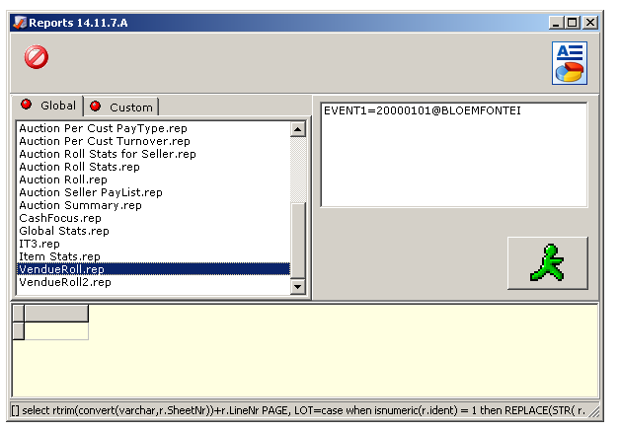

Print vendueroll

Select VENDUEROLL.REP (or any of the vendueroll reports listed) from Global.
Click to retrieve info
Click on the LOT column heading to sort the report in LOT order.
Click  to open/print the vendueroll in MS WORD

Print catalogue

Select CATALOGUE.REP (or any of the catalogue reports listed) from Global.
Click to retrieve info
Click on the LOT1 column heading to sort the report in lot order.
Click to open/print the catalogue in MS WORD

WE ARE NOW BE READY FOR THE AUCTION

STEP 6 – Buyer registration

If not running, start FlexiAuction and Login to correct datastore. Activate your event.


Click on CUSTOMERS on the top menu bar

Register your buyers from the registration cards that they completed.

Search for the buyer by typing his surname/name and then
press ENTER or

If the buyer is in the list, press up/down keys to highlight the buyer,
then right click and select “ ASSIGN BUYER NR (BSNR)”.
Enter the buyer number for this buyer from the registration
card and click YES.

If the buyer is NOT in your list, first add this new buyer to your list:
- Click +,
- Enter the name and other relevant details for this buyer.
- Enter the buyer number from your registration card
- Click SAVE

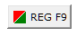
Click on “REG F9” or press F9 to view a list of registrations, add new registrations,
delete registration and export your registration list

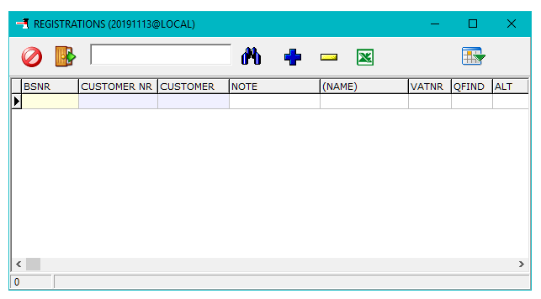

STEP 7 – Capture Vendueroll as the lots is sold.

If not running, start FlexiAuction and Login to correct datastore. Activate your event.


Click ENTER on a blank filter list to display all your sheets.

At this stage we need to fill in the BUYER and PRICE for each
LOT as this info is returned from the floor.

Highlight the lot you want to complete by pressing the up/down keys or
click on the lot.

Press ENTER or double-click on the highlighted lot to change it.
(or right-click and click on CHANGE LOT or press F2)

Fill in your price and bidding number and SAVE the lot.


REPEAT UNTIL ALL LOTS IS COMPLETED

Click for quick buyer/amount entry mode.
This will enable faster capturing of only the required buyer and price info.
Click again to disable (toggle)

Right-click and select “MULTIPLE BUYERS” if the lot contains multiple items,
and each of these items is sold to different bidders.

STEP 8 – Invoicing buyers and sellers

If not running, start FlexiAuction and Login to correct datastore. Activate your event.

Note that everywhere in the system customers is color coded:
GREEN IS BUYERS and RED IS SELLERS

The invoicing process is the same for
both buyers and sellers.

Click “PAY F10” of press F10 to invoice a customer
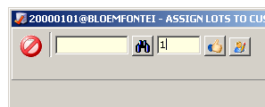

For sellers enter the customer number in the first entry box or find the customer,
For buyers enter the buyer number into the second entry box. Press Enter to display.

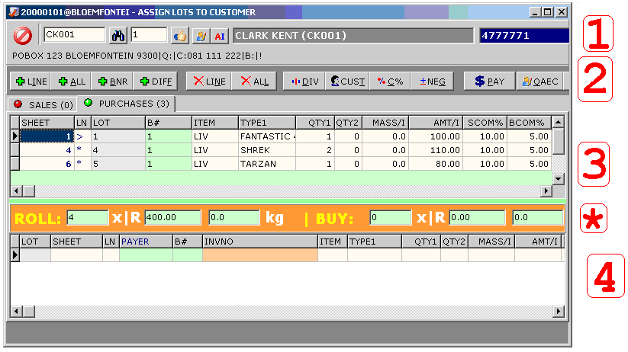

[1] | Customer info
[2] | Actions that we can perform to build the invoice:  +LINE : add only the highlighted lot to the invoice (dbl-click shortcut)  +ALL : add all lots to invoice  +BNR : only adds lots for a specific MARK to the invoice  +DIFF : add all the lots to the invoice that is not added already  XLINE : delete highlighted lot from invoice  XALL : delete all un-invoiced lots from the invoice  |DIV : divide a lot into two separate lots  CUST : Change the indented payee/payer on lots.  %C% - Change commission% on lots  ±NEG: Make lot positive/negative  $PAY: Make invoice for selected payer/payee  QAEC : Change customer info
[3] | The sales and purchases for this customer in separate tabs.
[4] | The lots that is included in the invoice that we are building.
[*] | Showing you if lots assigned is balancing with lots invoiced.  GREY if balanced, ORANGE otherwise

ALL
Click “+ALL” to copy all lots for the customer to the invoice.
The lots will be displayed in section [4]

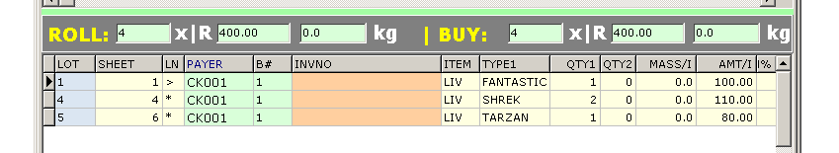

If the bidding price of a lot is below reserve, please right-click and select “STC Code”
To provide a reason for adding the lot.

$ PAY
Click on “$PAY” to invoice the highlighted customer with the lots displayed in the
invoice area [4]

ITEMS

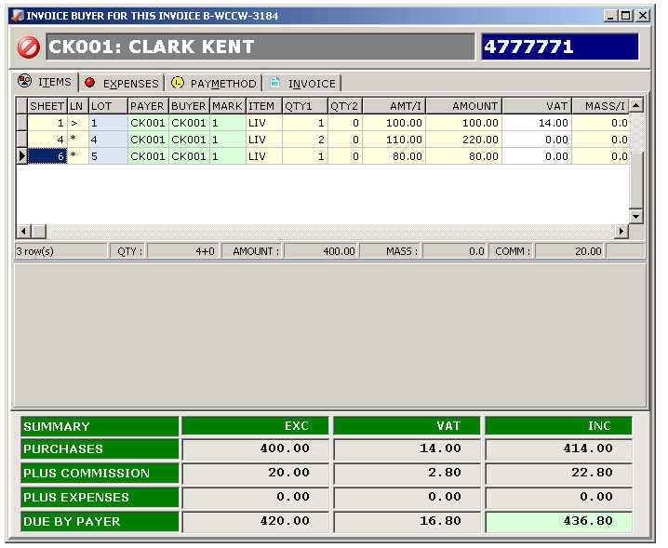

When the lots in this list is correct, click on EXPENSES to move to the next tab

EXPENSES

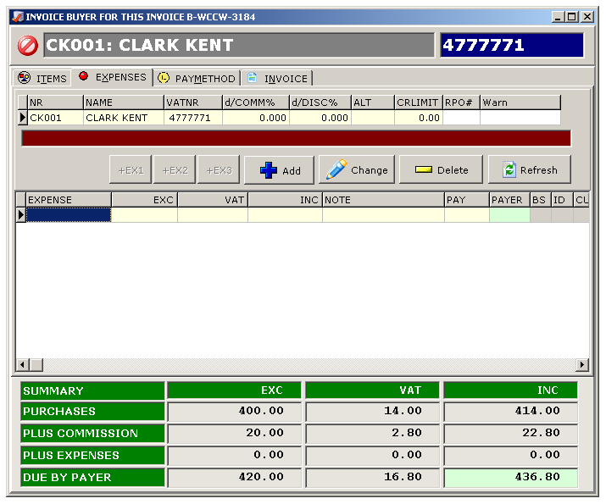

On this tab we can maintain any other charges or expenses to the customer:
- For Buyers: To deduct from the invoice total
- For Sellers: To add to the invoice total

e.g. bank charges, transport, advertising, RMLA, etc.

ADD- Add a new expense to deduct
CHANGE – Change the amount or type of the expense
DELETE – Remove the expense

When all expenses is completed, click on PAYMETHOD to move to the next tab

PAYMETHOD

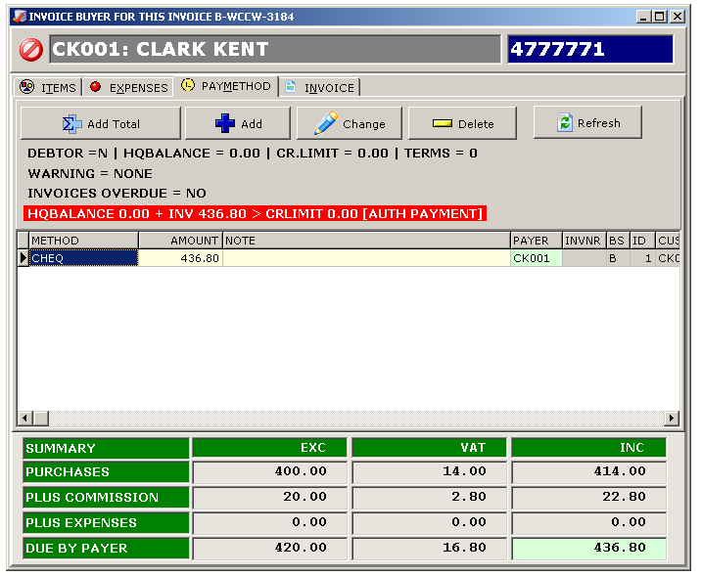

On this tab we can specify:
- For Buyers: How did the customer pay.
- For Sellers: How did we pay the customer

e.g. contras, cheques, cash, credit card, account, etc.

ADD- Add a new payment method
CHANGE – Change the amount or type of the payment method
DELETE – Remove the payment method
ADD TOTAL – Add the whole amount as a cheque.

When all expenses is completed, click on INVOICE to move to the next tab
FINALIZE/PRINT INVOICE

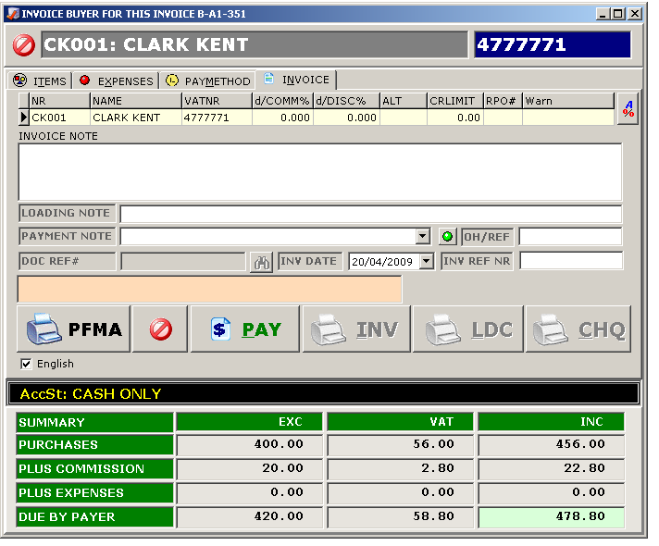

Add optional referenced invoice number, invoice date, payment and loading notes.

Click “PFMA” to print a pro-forma invoice
Click “PAY” to finalize the invoice. (Once finalized, no changes can be made.)
INV – print invoice (buyers/sellers)
LDC – print loading certificate (buyers)
CHQ – Print cheques (sellers)

Right click on the PFMA, INV and LDC to change to preview or number of pages to print (default printer)

To Delete an invoice: right-click on the Invoice and click “Delete Invoice ”in the previous window (Retrieve original invoices from your customer!!!)

To reprint invoices: TOOLS > VIEW INVOICES> Find relevant invoice > Reissue

To Change Payment: TOOLS > VIEW INVOICES > Find relevant invoice >
Right-click change PayType
STEP 9 – Balance the auction

If not running, start FlexiAuction and Login to correct datastore. Activate your event.

Right-click and select BALANCE on the main vendueroll to see if all lots if balanced,
or to see if there is still buyers that need to pay.

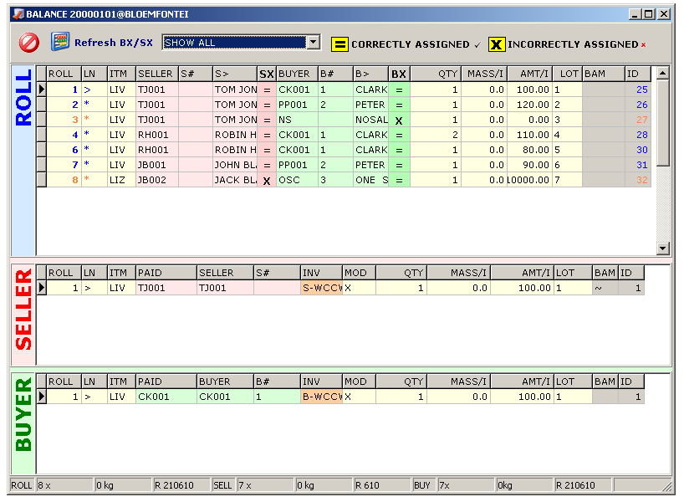

Click Refresh SX/BX

The lots will be displayed on top with either a “=” or a “X”
in the BX and SX fields,

Showing you if the sellers balance with assigned lots (SX) and
Buyers balance with assigned lots (BX).

Right click “PAY/INVOICE F10” to invoice uncompleted invoices.

Ensure that you have no Un-invoiced Assigned Buyer/Seller Lots
Right-lick to export for more options

All lots should be displayed with “=” if the auction is correctly balanced

STEP 10 – Print reports

If not running, start FlexiAuction and Login to correct datastore. Activate your event.


Click on REPORTS on the top menu bar

Select the required report from either Global or Custom
Click to retrieve info
Click (preferred if visible) or  to open/print the report

Always print the Auction Summary report first to ensure
that your auction is in balance.

STEP 11 – Backup your event to memory stick

If not running, start FlexiAuction and Login to correct datastore. Activate your event.

Insert your memory stick
Click on Events to open the Events maintenance form.
Highlight your event.
Right-click and select “Export to FXE” from the popup menu
Select you memory stick as location and SAVE the file.

STEP 12 – Backup your whole datastore

Insert your memory stick
Click TOOLS
Click MAKE A BACKUP
Click BACKUP
Select Folder on memorystick, then click OK
Click OK when finished.
PLEASE MAKE A BACKUPS OF YOUR DATA EVERY DAY

SUPPORT

HELPDESK
060 980 5555
www.flexiauction.com

PLEASE ENSURE THAT YOU READ OUR CUSTOMER AGREEMENT, WHICH MAY ADVERSELY AFFECT YOUR RIGHTS, AND LIMITS OUR LIABILITY UNDER THIS AGREEMENT, THE EXTENT OF WHICH MUST BE CONSIDERED CAREFULLY, AS ACCCEPTANCE THEREOF CONCLUDES THE AGREEMENT BETWEEN YOU AND WIBAKOR. BY ACCEPTING THE AGREEMENT YOU FURTHERMORE ACCEPT TO BE BOUND BY THE TERMS, WHICH FORMS A VITAL AND INTEGRAL PART OF THE AGREEMENT. THIS DOCUMENTE IS AVAILABLE ONLINE AT HTTP://WWW.FLEXIAUCTION.COM/CA
This document was last revised 16/11/2019 WK

